192521377-SUBASHREE.N
LAB EXPERIMENT
EXP 5:
SELECT with various clause WHERE pattern matching
OUTPUT:
1:
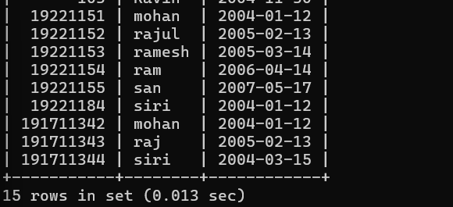
2:
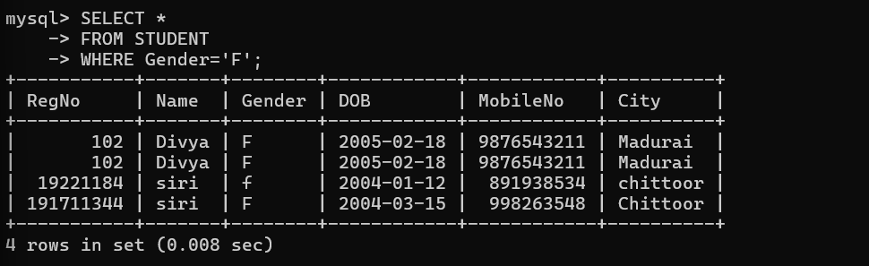
3:
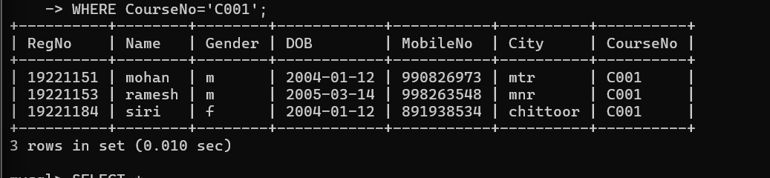
4:
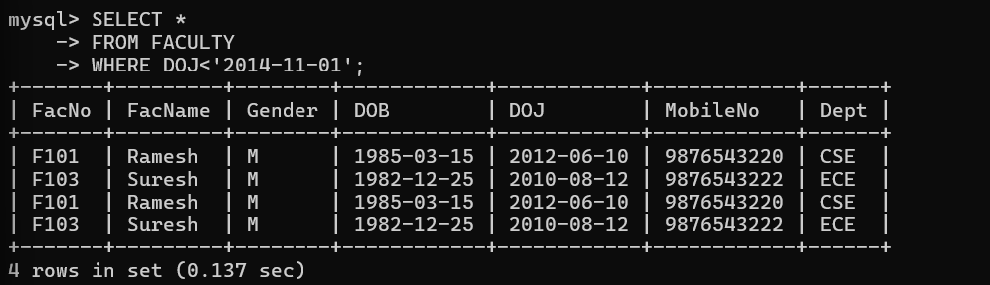

5:
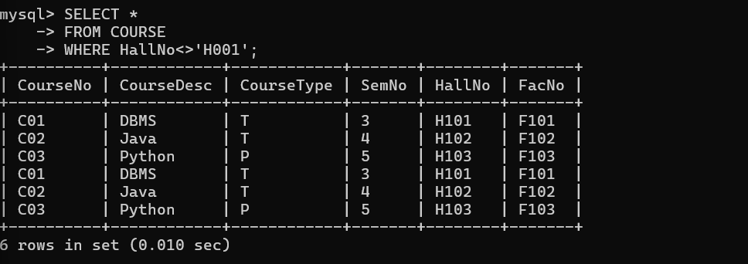

6:
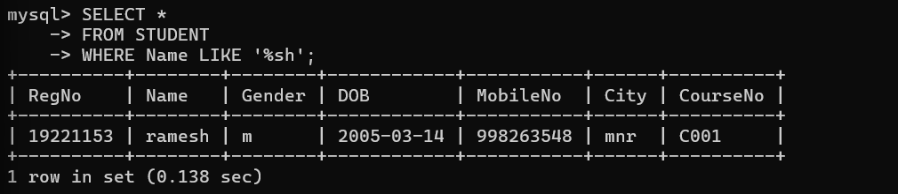
7:
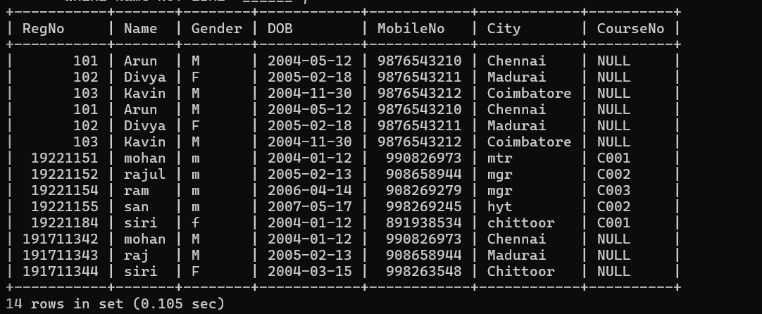
8:
